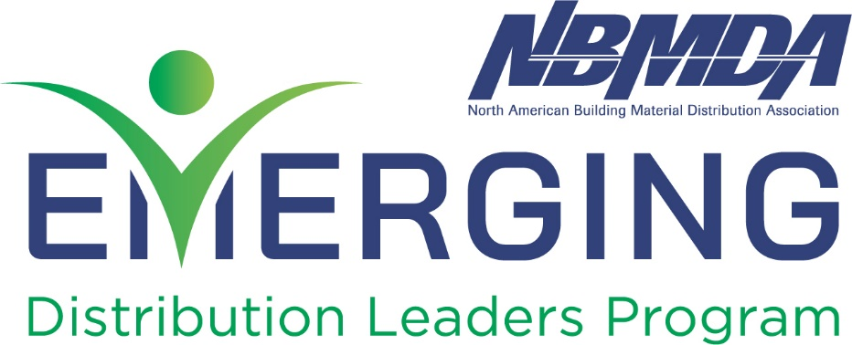
Program Application
Instructions:
The individual nominating someone for this program should complete this form. Upon completion, please return to info@NBMDA.org. Upon receipt, NBMDA will issue an invoice. Participation in the 2024 program is not final until this invoice is paid and confirmation is sent. The cost of the 2024 program is $3595.
The deadline to apply for NBMDA’s Emerging Distribution Leaders Program is April 1, 2024.
To graduate from the program, each student must participate in and complete each of the four segments of this program: University of Innovative Distribution (UID), NBMDA Master Manager Program, UID In-A-Day and the NBMDA Annual Convention.

Nominator Information:
First Name: Nominator’s first name
Last Name: Nominator’s last name
Title: Nominator’s position title
Company: Company name
Address:
Company’s street address
City, State, Zip
Phone (office): Office phone number
Phone (cell): Cell phone number
E-Mail: Work E-mail

Nominee #1 Information:
First Name: Nominee’s first name
Last Name: Nominee’s last name
Title: Nominee’s position title
Company: Nominee’s company name
Address:
Company street address
City/State/Zip
Phone (office): Office phone number
Phone (cell): Cell phone number
E-Mail: Nominee’s work E-mail
How many years has the nominee been in the industry? # of years

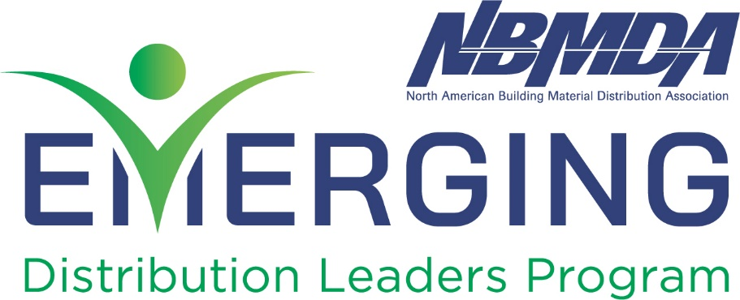

Nominee #2 Information:
First Name: Nominee’s first name
Last Name: Nominee’s last name
Title: Nominee’s position title
Company: Nominee’s company name
Address:
Company street address
City/State/Zip
Phone (office): Office phone number
Phone (cell): Cell phone number
E-Mail: Nominee’s work E-mail
How many years has the nominee been in the industry? # of years

Nominee #3 Information:
First Name: Nominee’s first name
Last Name: Nominee’s last name
Title: Nominee’s position title
Company: Nominee’s company name
Address:
Company street address
City/State/Zip
Phone (office): Office phone number
Phone (cell): Cell phone number
E-Mail: Nominee’s work E-mail
How many years has the nominee been in the industry? # of years

